**Lymphatic System – Notes**

* Fluid is forced from the bloodstream in the capillaries into the tissues due to high pressure.

The lymphatic system collects fluid in order to:

1. Return it to the blood stream.
2. Filter out disease-causing microorganisms.

The lymphatic system consists of:

* A network of lymph capillaries joined to longer lymph vessels.
* Lymph nodes located along the length of longer lymph vessels.

**Components of the lymphatic system**:

1. Lymph.
2. Lymphatic vessel:

– Lymphatic capillaries.

* Lymphatic vessels.
* Lymphatic trunks.
* Lymphatic ducts.

1. Lymphatic organs:

* Thymus.
* Lymph nodes.
* Spleen.
* Tonsils.

1. Lymphatic cells.

* The lymph ducts are the structures that drain back into the heart.
* The lymphatic cells consist of lymphocytes. They live inside the lymph nodes and help to destroy pathogens.

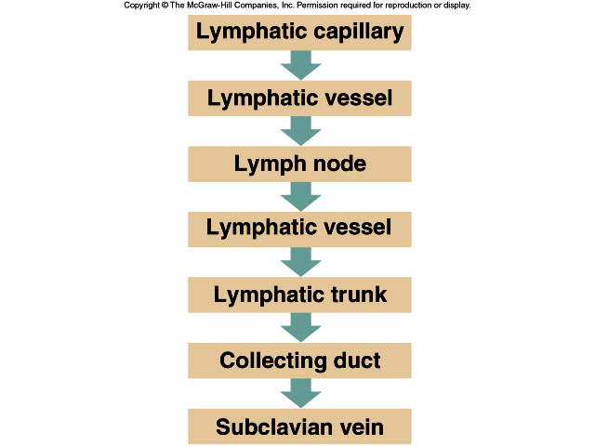

* **Lymph**: Tissue fluid (interstitial fluid) that enters the lymphatic vessels.
* Lymph is similar to plasma.
* Contains large proteins and disease-causing microorganisms.

**Lymphatic capillaries**:

Features of the structure of lymphatic capillaries:

* Blind end.
* Single layer of overlapping endothelial cells.
* More permeable than that of blood capillary.
* The network joins to form 2 large lymphatic ducts that empty lymph into the Subclavian veins.

**Lymph nodes**:

* Also called lymph glands.
* Occur at intervals along lymphatic vessels.
* Most numerous in the neck, armpits, groin and around the alimentary canal (digestive tract).
* Capsule of connective tissue forms a network.
* Contains masses of lymphoid tissue – cells known as lymphocytes, macrophages and plasma cells.
* Lymph vessels rely on skeletal muscle movement to transport lymph back into the circulatory system.

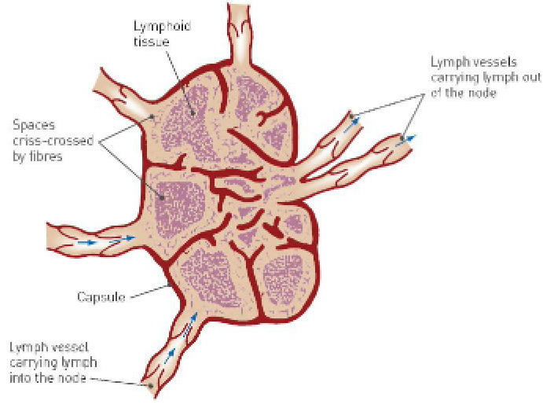

**Role of the lymphatic system in defence against disease**:

* Lymph entering nodes contains cell debris, foreign particles and microorganisms.
* Some can cause disease.
* Larger particles are trapped in lymphoid tissue.
* Macrophages consume these by phagocytosis.
* During infection, the numbers of lymphocytes increase, and the lymph nodes become sore and swollen.
* Infection in the finger may cause painful swelling in the armpits.

